

**Description**

**O**ur project is a DoS Connection Monitor with the added feature of blocking malicious IPs on operating system that support it. The program gives the user an overview of TCP connections opened and established on the his or her system. The intended use of this program is to help prevent poor performance of a web server if the network administrator suspects it is under a Denial of Service attack. Using the program, the network administrator can view active connections made to the machine. Upon locating the suspected malicious IP, the user can then block attempts to make connections to the user’s system by submitting the IP in the “block IP” text field. The program, through system level commands, blacklists that IP in the system’s Route Table. This prevents further requests for connections from the malicious IP and frees resources on the server as a result.

**W**e used Xamarin Studios for its Mono Development Toolkit which allowed us to build a native GUI on top of the .NET framework using C#. This let us build a program for both Windows and UNIX based systems.

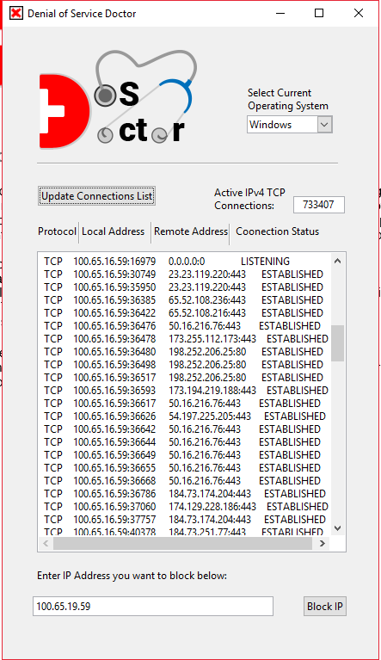 **W**indows 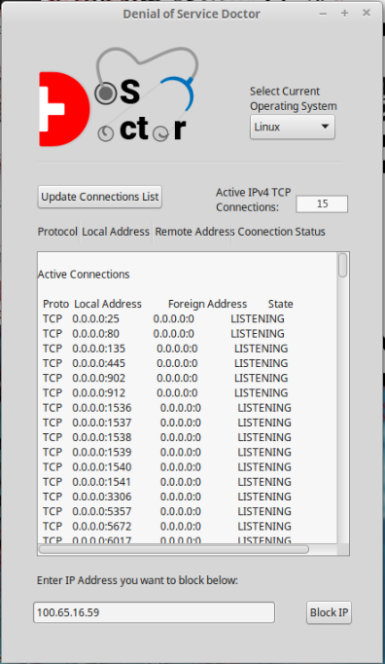 **L**inux

**Contributions**

**Troy**

* Project planning
* UI Mockup and GUI Design
* Logo and report graphics
* Linux Apache server installation, configuration, and management
* Active-Connections output Scanner

**Albert**

* Project planning
* GUI Design
* Developed Command and Terminal window functionality
* UNIX scripts and terminal interfacing
* Implemented block IP feature
* Wireshark capture analysis

**Dylan**

* Formatted TCP connections to show desired output
* Created netstat bash script file
* Batch file construction
* Scribe and documentation of resources used throughout the project
* Helped debug

**Related to Class:**

**T**he basis of our project was simulating a DoS attack which can be blocked by disabling the TCP connections that were continuously connecting to our server. The idea behind a DoS attack is to create multiple TCP connection instances of pending the three-way handshakes. Host A starts by sending a SYN packet to Host B to open the connection. Host B responds by sending SYN-ACK packet, but host A doesn’t send the ACK packet back to confirm a successful connection. Not responding to Host B means that bandwidth is being used and processing resources expended keeping the initialized pending connections open thus decreasing server performance and causing poor network response time. After finding a program to produce this attack we used wireshark with a TCP & specified IP capture filter to test the validity of the attack. After multiple tests, we concluded that the program would work for our project. This project is related to the class by showing our understanding of the Data-Link layer, Transport layer, Routing Tables, and TCP connections.  We’ve built a program that runs Windows and Unix commands to allow us to filter the specific IPs using TCP connections on our system. Using wireshark we are able to verify the TCP connections that are being made to a server. Our program can block these connections by entering their IP address.

**Software used:**

**(Windows)**

**Windows 10, 8, 7**

**Mono Development Library 5.10**

**.NET Library**

**GTK Toolkit**

**Xamarin Development Studios**

**WireShark**

**Low Orbital Ion Cannon (DoS Attacker)**

**Visual Studios**

**(UNIX)**

**LinuxMint**

**Apache Server 2.2**

**Mono Development Library 5.10**

**Terminal Commands used:**

**(Windows)**

**>$ netstat -an**

**>$ netstat -s**

**>$ route DELETE 255.255.255.255**

**(UNIX)**

**>$ netstat -anp |grep 'tcp\|udp' | awk '{print $5}' | cut -d: -f1 | sort | uniq -c | sort –n**

This command checks to see if you are under a Dos attack by checking the IPs that have connected and displays how many connections are to each IP.

**>$ netstat -n | grep :80 |wc –l**

This shows the number of active connections that are open to your server.

**>$ iptables -A INPUT 1 -s 255.255.255.255 -j**

  This command blocks the IP address that is entered.

**Command Glossary:**

**netstat** - Displays the active TCP connections, ports, IP routing tables, IPv4 and IPv6 statistics for your computer

**-a** - All command to show listening and non-listening sockets

**-n** - Show numeric addresses and port numbers

**-p** - Displays the name of the connections that is being specified

**|** - Pipeline that helps denote a new separate process to run

**grep** -  Print lines that match a pattern

**awk** - Pattern scanning and processing language for terminal

**print$5** - Prints out the fifth column of the listings from awk

**cut** - Removes sections from each line of the file

**-d** - Field delimiter

**-f** - Selects only those fields that are specified

**sort** - Sorts the lines of the text

**uniq** - Omits repeated lines

**-c** - Count that prefixes the number of lines by the number of times it occurs

**wc** - Prints a newline, word, and byte count for each file

**iptables** - Administrative tools for IPv4 packet filtering

**-a input** - Appends the table for further changes

**delete** - Deletes an item from the table

**-s** - Display summary statistics for each protocol

**-j** - Drop functionality for the table

**Software in Action:**

**{ATTACKER’S Computer(Windows 10)}** 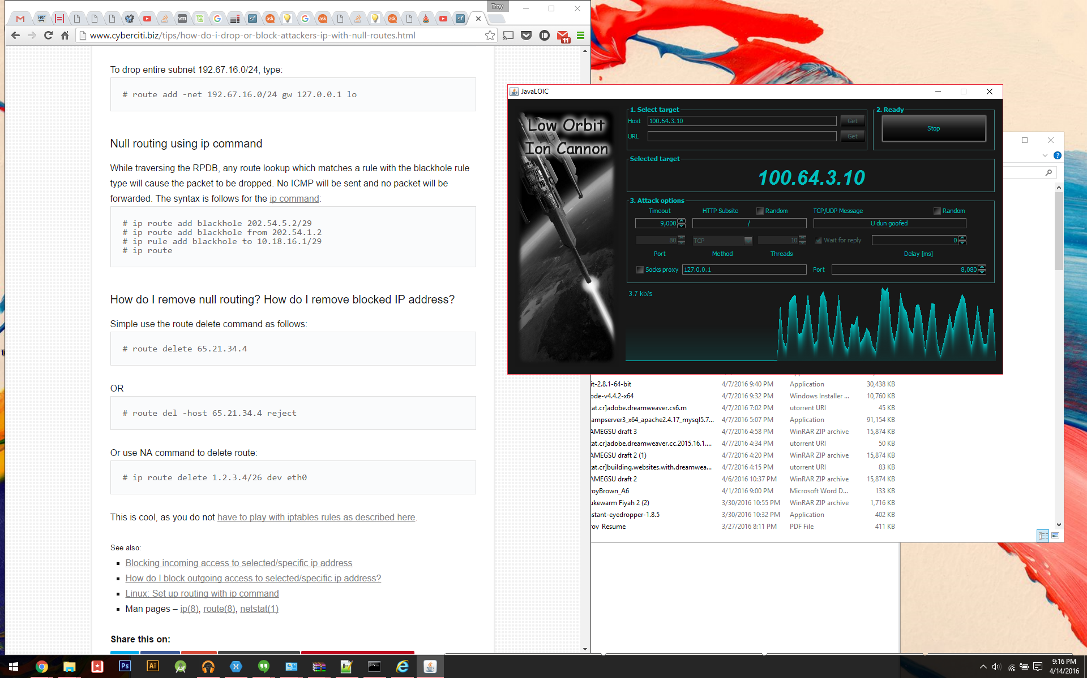

**-Low Orbit Ion Cannon (program used to simulate DoS attack) set up with targeted server’s IP address locked on.**

**-TCP packets are being sent through and are shown in their intensity in the graph.**

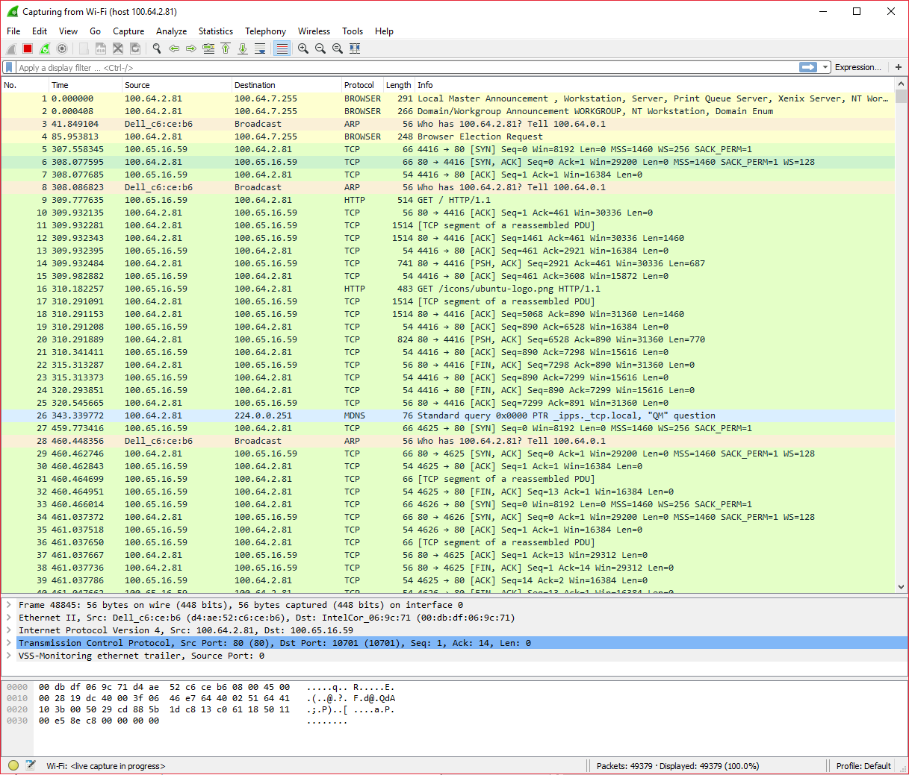

**-WireShark view with Filter for DoS attacker’s IP set**

**{SERVER (LinuxMint)}**

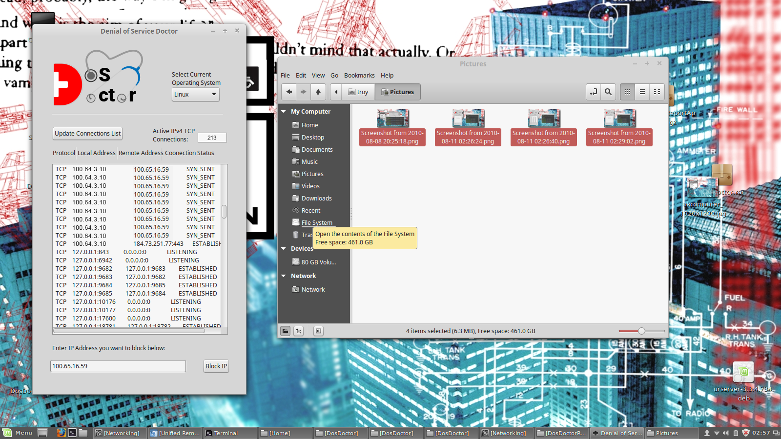

**-Current DoS Attack in action**

**{SERVER (LinuxMint)}**



**-Current Active Connections before block**

**-IP user wants blocked is entered and block button pressed**

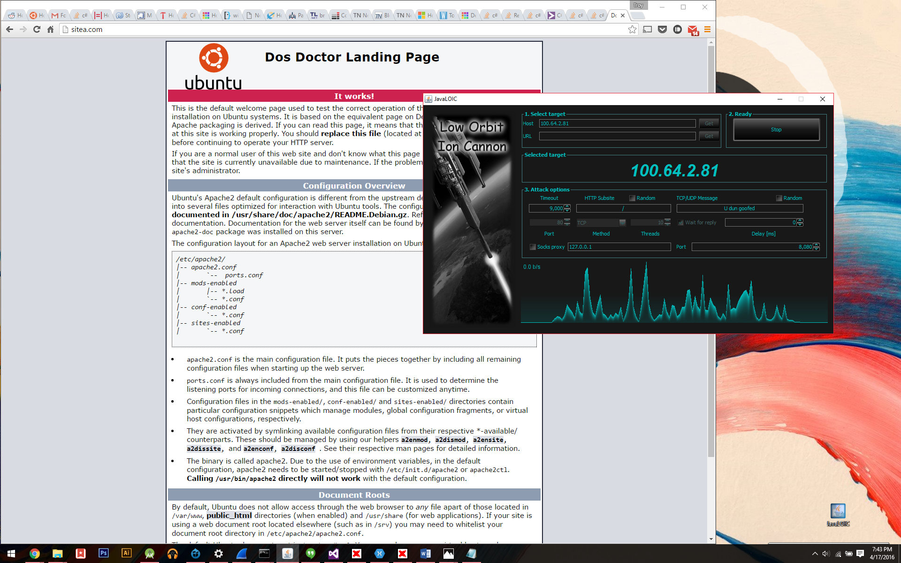

**Attacker’s network activity drops off at the point of block**

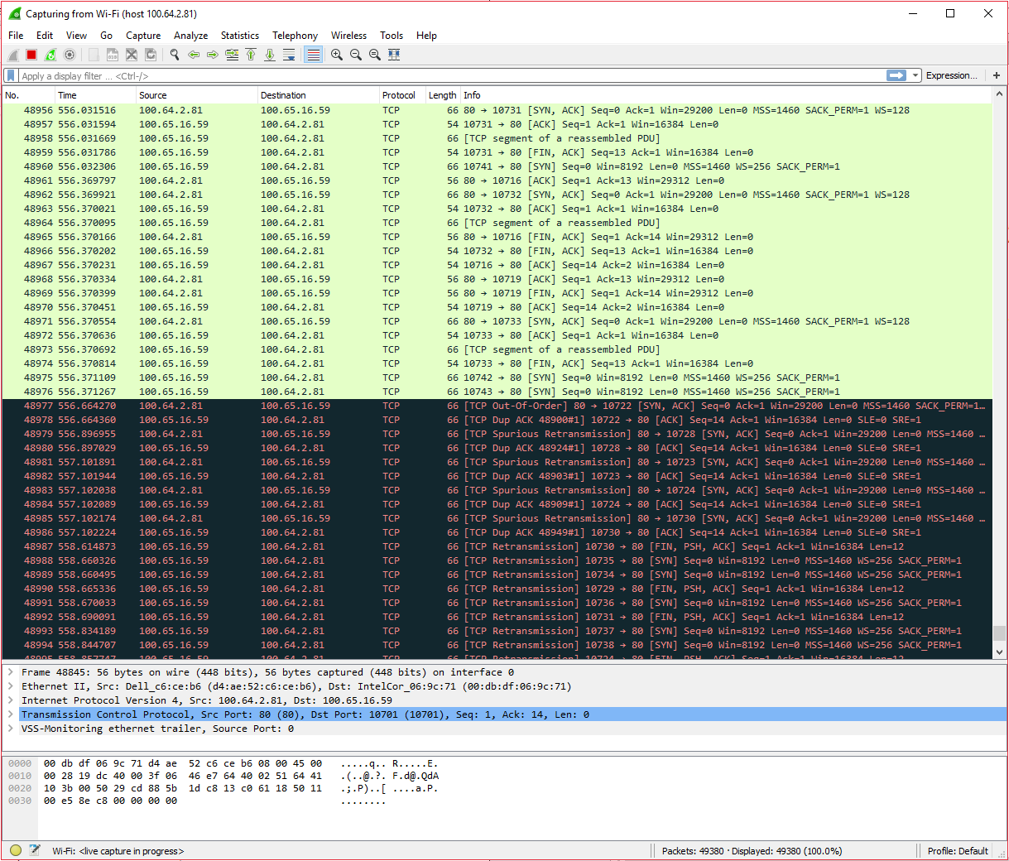

* **Point at which the attack has been halted by the block on the server.**

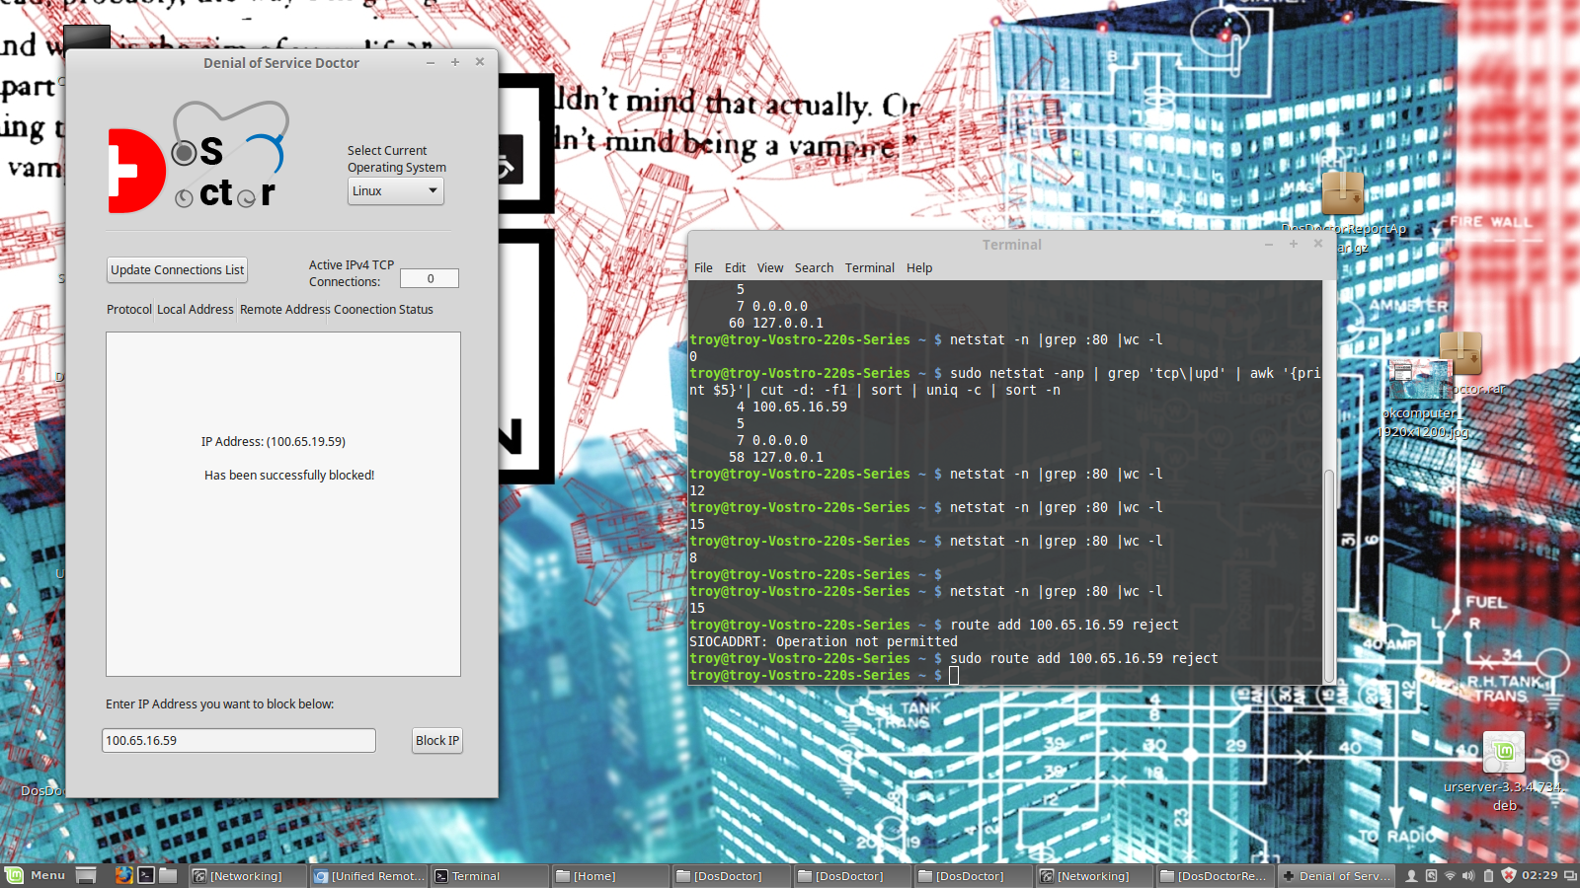

* **Zero active connections after malicious IP has been blocked**

**-Confirmation of blocked IP for user**

**-Update connections button can then be pressed to view new connections on server**

**{ATTACKER’S Computer(Windows 10)}**

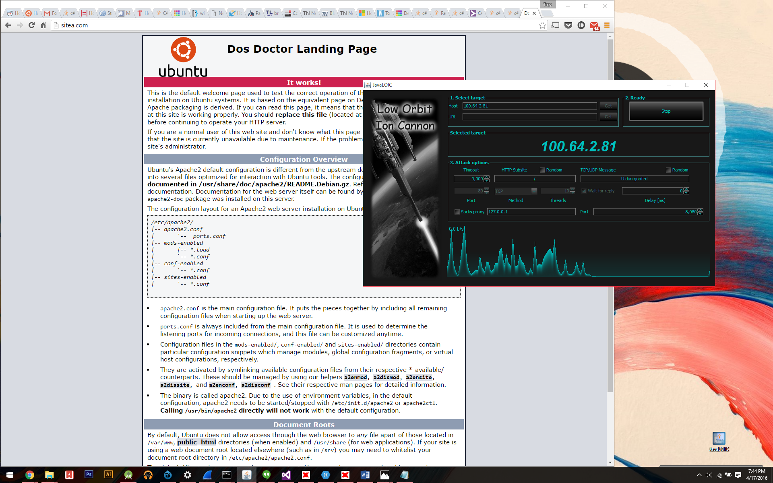

**Confirmed dead attack**

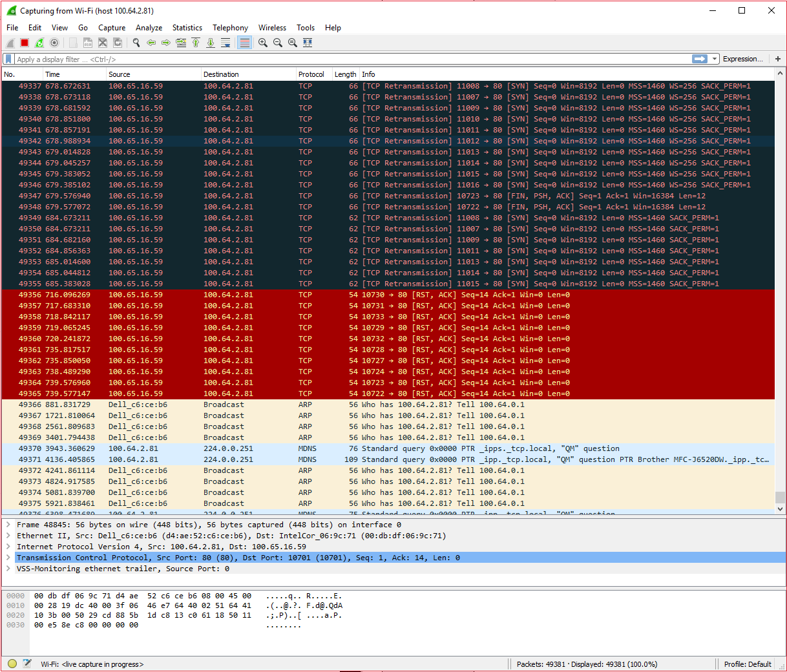

**-TCP Connections failing to get ACK’d getting terminated**

**SERVER (LinuxMint)}**

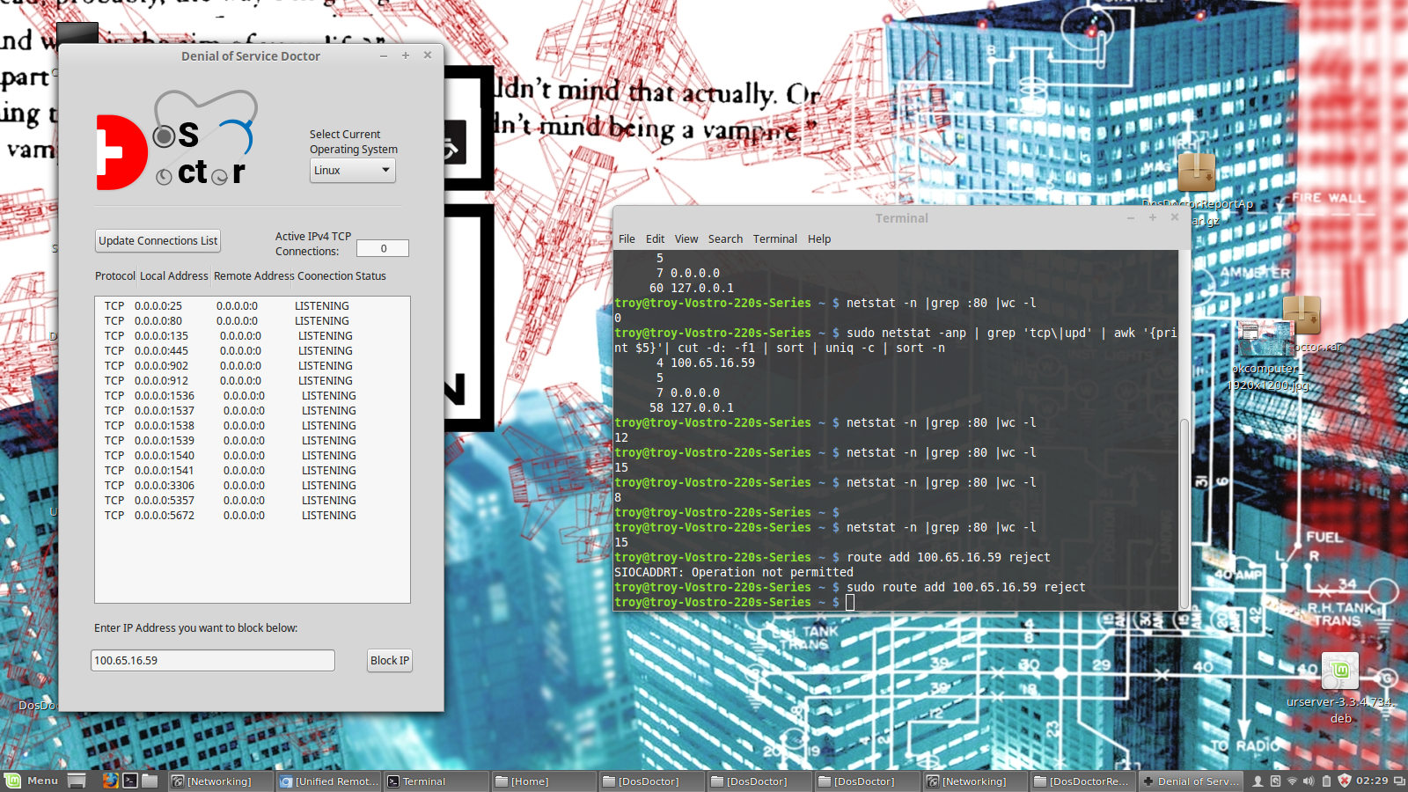

**-Connections cleared and resources freed !**

**Problems during project**

One of the first problems we ran into was finding software that would allow us to run both Windows and Unix commands. Mono Development helped us solve this problem as stated earlier in the report. Next came implementing Unix code into our Dos Doctor program. We discovered there are packages within the IDE that allow you to start processes from different OS’s. In our case it’s using Windows to run Unix commands. The use of personal computers posed another problem because we have Windows 7, 8, and 10 that can run the windows commands. However, we don’t have a Windows server which has fewer restrictions on blocking IPs. Our personal computers won’t allow us to block IPs unless it was running from a Windows server. Another important issue that occurred was the elevation of privilege. The commands in our program won’t work unless the user is an administrator or has administrator privileges. These were the major issues we encountered during our project.

**Areas to Improve**

In a perfect world where we could have flawless code that does everything we would want it to when we wanted it to, we would add several more features to this project. Firstly, we would make the program able to work in the background of other applications that way the user can monitor their connections and can be notified whenever a large number of connections is being sent to the server. The next feature we would have is the ability to type in your own unix commands into a text box to run. There would be a selection of netstat commands to run to view personal diagnostics. Another feature that could be added is to select different protocols to view such as TCP or UDP. We would also like to add the ability to use Windows Server so that the program can run with more freedom. Windows server uses Network shell which is a command line utility that allows you to configure display statuses of various network communications. With this, an IP address could be inputted to the program that is then put into a netshell command line to perform various tasks such as adding a specified IP to a Route Table to block/reject it. With more time we could add these features and even commercialize this program.

**References**

Stetic GUI Designer. (n.d.). Retrieved April 4, 2016, from http://www.monodevelop.com/documentation/stetic-gui-designer/

Otey, M. (2012, February 21). Top 10: Windows Firewall Netsh Commands. Retrieved April 7, 2016, from http://windowsitpro.com/windows-server/top-10-windows-firewall-netsh-commands

Gite, V. (2008, November 21). Detecting DoS / DDoS Attack on a Windows 2003 / 2008 Server. Retrieved April 7, 2016, from http://www.cyberciti.biz/faq/detect-ddos-dos-attack-on-windows-server/

Laurie, V. (2012). Netstat. Retrieved April 7, 2016, from http://commandwindows.com/netstat.htm

Netsh AdvFirewall Firewall Commands. (2009, August 6). Retrieved April 13, 2016, from https://technet.microsoft.com/en-us/library/dd734783(v=ws.10).aspx

How to use the "netsh advfirewall firewall" context instead of the "netsh firewall" context to control Windows Firewall behavior in Windows Server 2008 and in Windows Vista. (n.d.). Retrieved April 13, 2016, from https://support.microsoft.com/en-us/kb/947709

Stackoverflow. (2014, August 20). Retrieved April 15, 2016, from http://stackoverflow.com/questions/9432108/c-sharp-read-line-from-file-with-streamreader-with-downloadfileasync